Step1:
Bring up mongodb by using the command:-
C:\Program Files\MongoDB\Server\5.0\bin>mongod

{"t":{"$date":"2021-12-11T09:18:30.255+05:30"},"s":"I", "c":"CONTROL", "id":23285, "ctx":"main","msg":"Automatically disabling TLS 1.0, to force-enable TLS 1.0 specify --sslDisabledProtocols 'none'"}
{"t":{"$date":"2021-12-11T09:18:30.310+05:30"},"s":"I", "c":"NETWORK", "id":4915701, "ctx":"main","msg":"Initialized wire specification","attr":{"spec":{"incomingExternalClient":{"minWireVersion":0,"maxWireVersion":13},"incomingInternalClient":{"minWireVersion":0,"maxWireVersion":13},"outgoing":{"minWireVersion":0,"maxWireVersion":13},"isInternalClient":true}}}

Screenshot of mongod
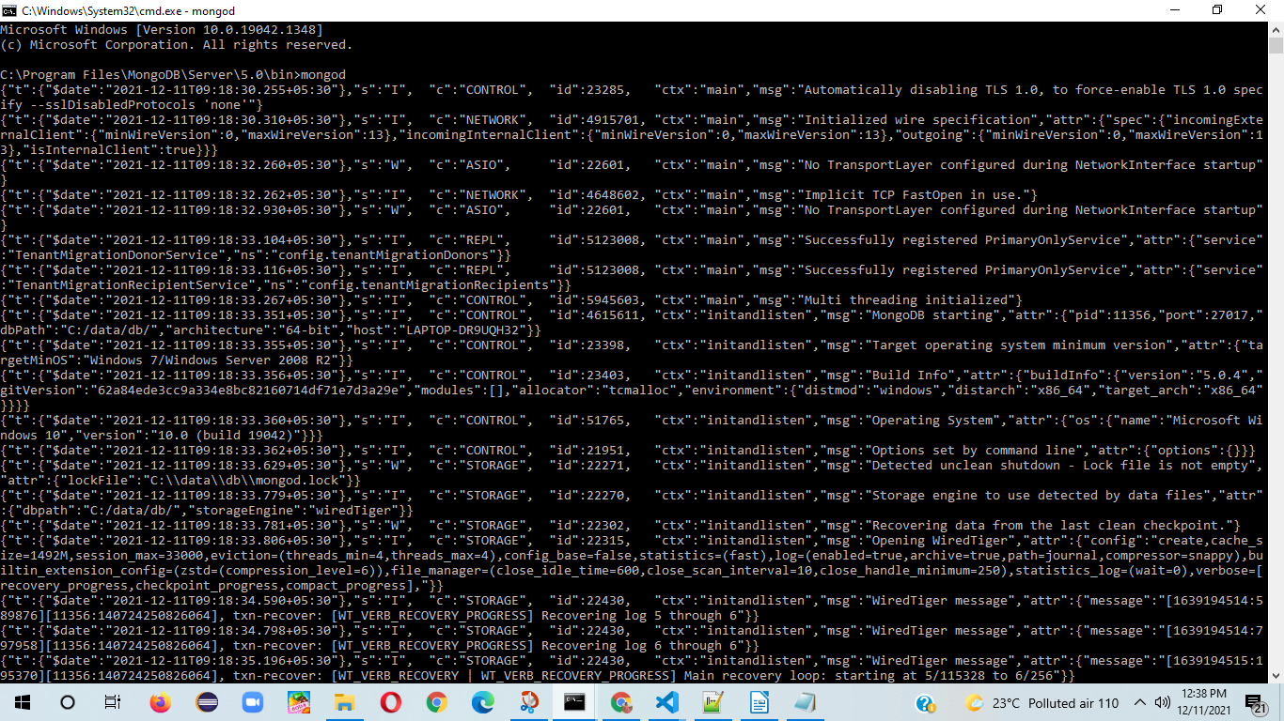

*********************************************************************************

Step2: Start Backend server(Express Js to connect Mongo DB) -Mean stack server
Provide below Command:
a) npm install
b) npm start

D:\Kitchen-Store-Angualar\online food order\OnlineFoodOrderingSystem-backend-expressjs>npm start

> online-food-order-system@1.0.0 start
> node server.js

Listing onnn port 3000
database connected
(node:6512) DeprecationWarning: collection.ensureIndex is deprecated. Use createIndexes instead.
(Use `node --trace-deprecation ...` to show where the warning was created)

Screenshot

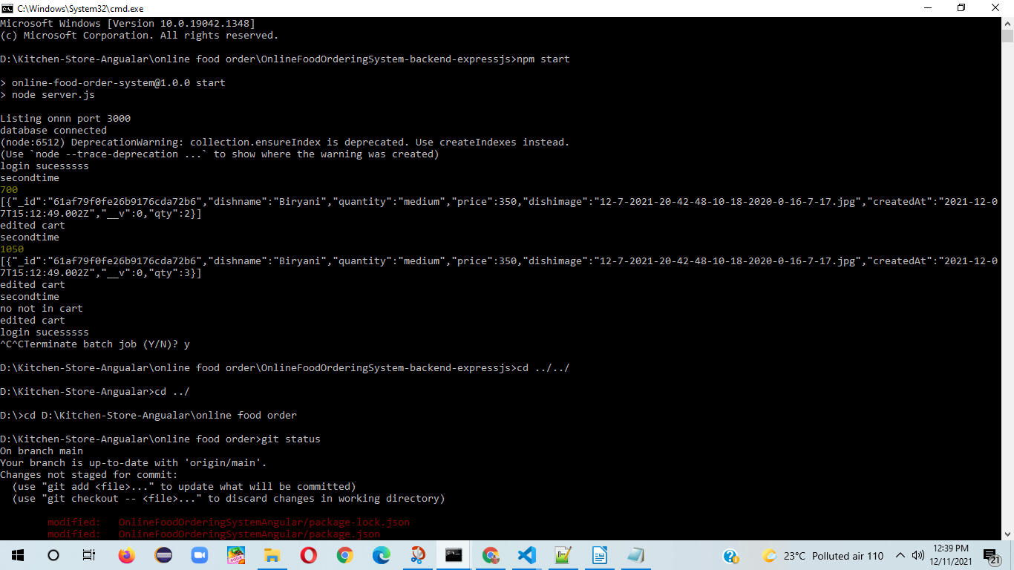

*********************************************************************************

Step3: Start angular application
Provide below Command:
a) npm install
b) ng serve

D:\Kitchen-Store-Angualar\online food order\OnlineFoodOrderingSystemAngular>ng serve
Your global Angular CLI version (13.0.3) is greater than your local version (10.1.6). The local Angular CLI version is used.

To disable this warning use "ng config -g cli.warnings.versionMismatch false".
10% building 3/3 modules 0 active(node:7620) [DEP0111] DeprecationWarning: Access to process.binding('http_parser') is deprecated.
(Use `node --trace-deprecation ...` to show where the warning was created)
(node:7620) [DEP0148] DeprecationWarning: Use of deprecated folder mapping "./" in the "exports" field module resolution of the package at D:\Kitchen-Store-Angualar\online food order\OnlineFoodOrderingSystemAngular\node_modules\tslib\package.json.
Update this package.json to use a subpath pattern like "./*".

chunk {main} main.js, main.js.map (main) 626 kB [initial] [rendered]
chunk {polyfills} polyfills.js, polyfills.js.map (polyfills) 141 kB [initial] [rendered]
chunk {runtime} runtime.js, runtime.js.map (runtime) 6.15 kB [entry] [rendered]
chunk {scripts} scripts.js, scripts.js.map (scripts) 102 kB [entry] [rendered]
chunk {styles} styles.js, styles.js.map (styles) 89.2 kB [initial] [rendered]
chunk {vendor} vendor.js, vendor.js.map (vendor) 3.32 MB [initial] [rendered]
Date: 2021-12-11T04:22:51.591Z - Hash: 42da3a1aba086c6d8549 - Time: 34951ms
** Angular Live Development Server is listening on localhost:4200, open your browser on http://localhost:4200/ **
: Compiled successfully.

Screenshot:-

